Maths

Summer 2 Week 4 22.6.20
Activity 1-
Battleships treasure. Using the grid, hide some treasure on one of the squares and try to find your partner's treasure by taking it in turns to guess the number. Eg Is the treasure on number 16?
Activity 2-
Ascot. With the beginning of Ascot last week, discuss racing and ordinal numbers when crossing the finishing line. Listen to the description and see if you can colour in the correct horses in their order.
Activity 3-
Cut out some shapes and sort them using the Venn diagrams. Look at their properties, e.g. corners, sides, points.

Activity 4-
Paper chain number bond to 10. Write some numbers on strips of paper. Work out which ones add up to 10. Link them together and attach your anchor. How many different ones can you make.
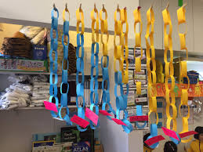
Activity 5-
Tally. How many times can you sprint/run/gallop in 1 minute. Can you improve your total over the week?

