Topic

Summer 2 Week 5 29.6.20
Activity 1-
Paint a parrot. Using the template, see if you can paint a realistic parrot. Go online or look at a book to see what a parrot looks like and use the appropriate colours. You can accessorise your painting by adding feathers/eyes etc.

Activity 2-
Egg and spoon race. Set yourself a challenge of moving over an obstacle course without dropping your egg. Return to the beginning of the course if you do.

Activity 3-
Explorers role-play. Make your own binoculars/telescope. Use rolled up paper and decorate it using paint/paper/tape etc. Go into the garden or go for a walk and see what you can spy. Perhaps you could bring along a compass or magnifying glass if you have one.
Did you notice anything new? If so, what was it? Could you do a detailed drawing of an animal or plant you found?

Activity 4-
Identify and name the common animal categories. E.g. reptiles, mammals, birds, fish, amphibians, invertebrates. Have a discussion about how to classify each animal and have a go at sorting them into groups. Look online, draw your own, or use the work sheep provided.

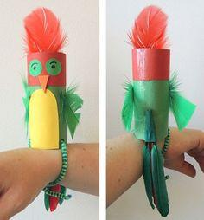
Activity 5-
Make your own Pirate Pet Parrot! Paint a loo roll with reds and greens, or blues and yellows. Add feathers for the tail, wings and crest. Poke two holes at the bottom and thread a pipe cleaner through each hole to tie around your arm.

