Topic - Summer 2 Week 1 1.6.20
Activity 1-
Learn about the different job’s pirates had on board their ship. Have a look at the PowerPoint, and have a go at drawing a pirate. Colour or paint your pirate carefully.
Think about which pirate you have chosen. What job does she/he do? Can you give her/him a funny pirate name? See if you can write the name underneath.

Activity 2-
Fill a tray or bowl with couscous, and hide metallic objects buried underneath e.g. scrunched up tin foil, paper clips, coins, teaspoon.
Have a go at finding out which items are magnetic and which ones aren’t (You could use a magnetic toy train, magnetic letters, or fridge magnet).
Are all metallic objects magnetic? Send us a photograph of all the items that you discovered are magnetic.
https://www.bbc.co.uk/iplayer/episode/b081m9q1/maddies-do-you-know-series-1-21-magnets-and-teddy-bears
Watch the first 6.30 minutes of Maddie’s Do You Know clip to see how magnets work.

Activity 3-
Watch Swashbuckle on iplayer. https://www.bbc.co.uk/iplayer/episodes/b04962fm/swashbuckle?page=2
Have a go at dancing like a pirate. https://www.youtube.com/watch?v=oe_HDfdmnaM

Activity 4-
Download the Bee-Bot app on your phone or tablet (it’s free!).
Programme the bee to move. Think about where the bee has to go first,
e.g. forward 2, turn, forward 1, then give the bee its directions.
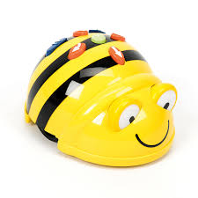

Activity 5-
Research project. See if you can find out about a famous pirate. What were they called? What ship did they sail? What did their flag look like?
See if you can make a collage of information or a document on the computer together. Print out or draw what you found out.
You could have a go at making their flag too.

