Topic

Summer 2 Week 4 22.6.20
Activity 1-
Sinking and floating. Explore materials that float and sink. Make predictions and see if your predictions are correct. Discuss properties and materials. Will an object that is heavy always sink? Test a pencil, rock, pinecone, bubble wrap, metals. Research the materials of boats and ships. Why do they float? You could watch this episode of Kit and Pup to get you thinking:
https://www.bbc.co.uk/iplayer/episode/b0bc29rr/kit-pup-series-1-7-floating-and-sinking
Activity 2-
Research and learn about different famous explorers. Where did they go? Did they discover anything?
Discuss what a Coat of Arms is. Did any of your explorers use or gain a Coat of Arms? Pretend to be an explorer. What would you have discovered? Would it be a new country, a new plant or creature? Perhaps you could imagine a new discovery. See if you can make your own Coat of Arms using the template on the website. What would you like on yours? How would you like to represent you and your explorations as an explorer?
Activity 3-
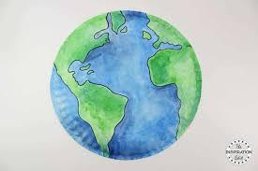
Look at the globe. Discuss the poles and the equator. Decorate a paper plate to look like the globe. Label on top of the plate to explain the hottest and coldest part of the globe. See image below. Write the words: hot, cold, warm, cool, equator, water, land.
Activity 4-
Ordinal numbers. Pretend to be Ascot horses. Challenge yourself and the members of your family to sprint like horses in a race. See if you can make any hurdles and practise jumping over them while running.

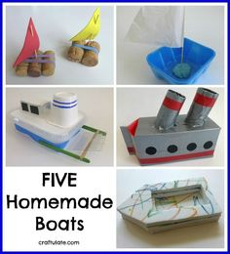
Activity 5-
Compare and investigate how boats were powered in the past. Have a go at making your own models of a sailing boat and a paddle powered boat. Here are some images to inspire you.

