All about ...
Rainforest Deforestation

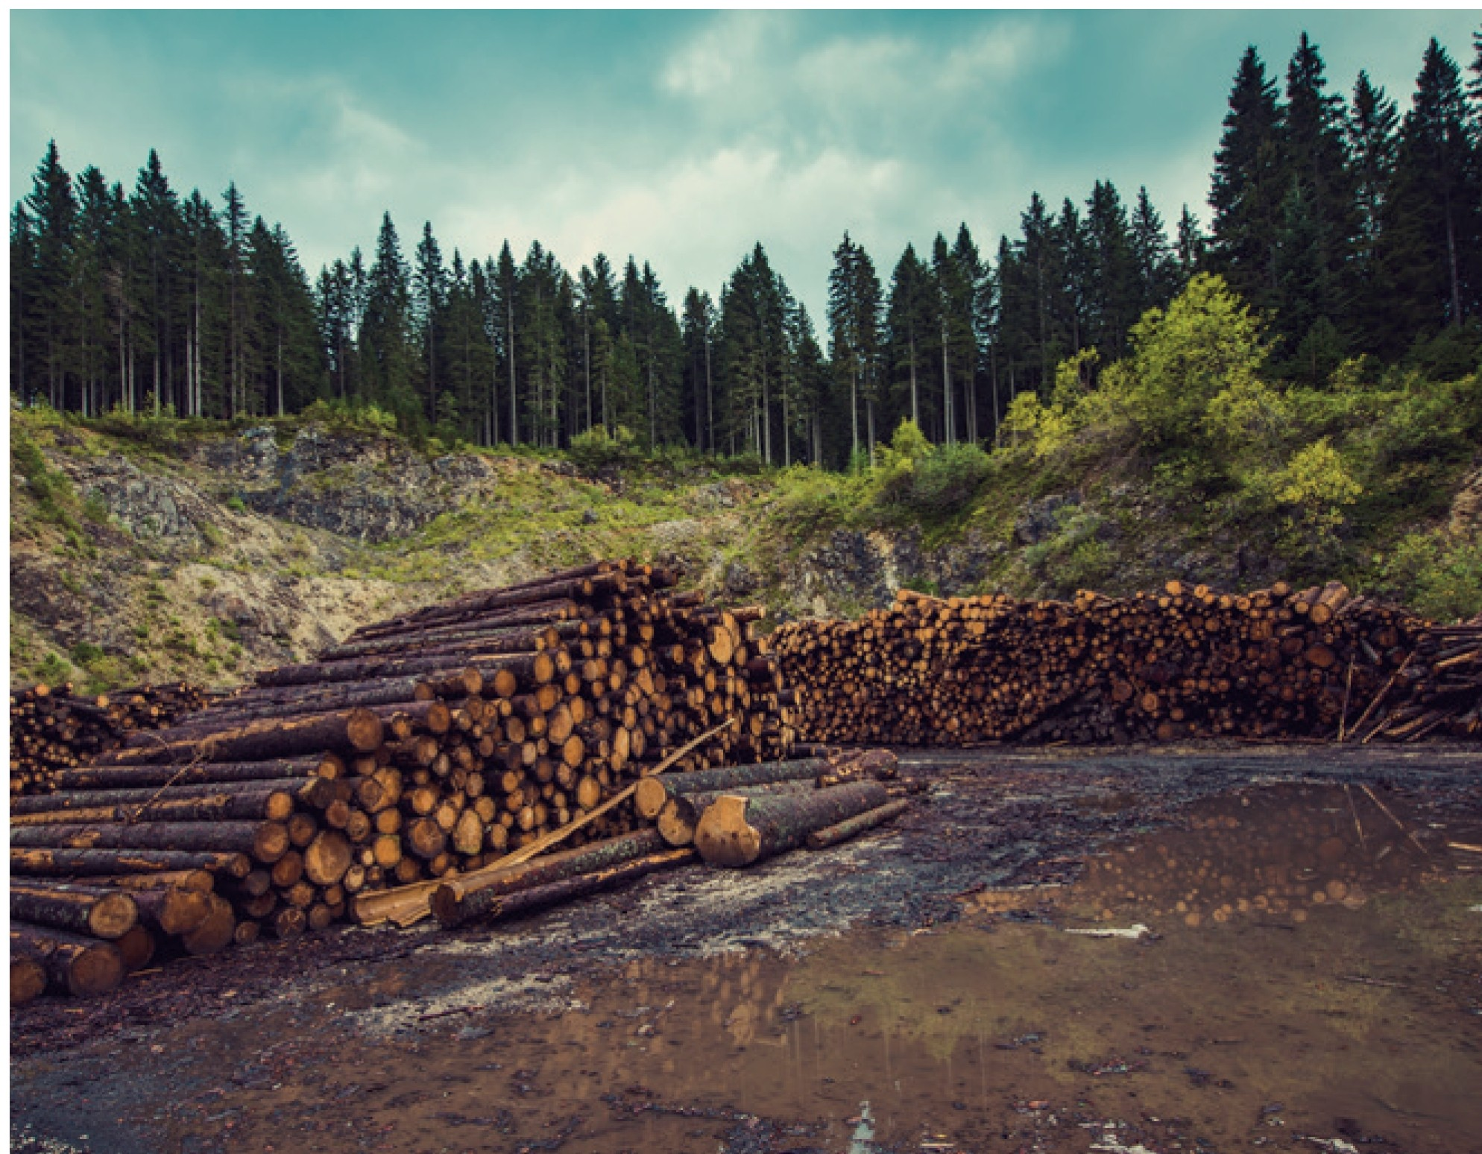
Rainforests are an essential part of our planet, providing oxygen, absorbing carbon dioxide and housing 50% of the animal and plant species of the planet. Not to mention, the medicines and cures that are made using plants only found in a rainforest environment.

Deforestation
Deforestation is the name given to the destruction of the rainforests and this is being done by burning them, chopping down the trees, or in some cases, flooding the areas. This is happening so fast that an area the size of twenty football pitches is being destroyed every minute! If the current rate of deforestation continues, it will take less than a hundred years to destroy all the rainforests on Earth.
Fact File in Numbers
20% of the world's oxygen is produced in the Amazon forest.
28,000 species of animals are expected to become extinct in the next 25 years due to deforestation.
½ of the tropical rainforests that we had have already gone.
Why are they being destroyed?
The biggest reason rainforests are cleared is to make space for food, including cattle to be farmed for cheap beef and also growing large crops, such as soya beans and palm oil. In addition, other causes of deforestation, which are also related to making money include; chopping down and using the wood from the forest, building roads for mining metals, gold or diamonds, flooding areas to make dams to generate electricity and also digging for oil.

How can they be saved?
There are plenty of charities fighting against deforestation and people can always help by raising money for those charities. Also, think about the reasons that the forests are being destroyed and how some little changes in your everyday habits could help. For example, the cheap beef farmed in the areas that used to be rainforest land is often used in fast food chains. Could you avoid eating fast food from these outlets? You could also check on your supermarket food labels for the country of origin of any meat you buy. Was it farmed in an area where deforestation is taking place? You could also use rainforest-friendly wood so you know it is not a by-product of deforestation. Finally remember, paper comes from trees so any paper saving you can do, as well as recycling, will help the environment.

•·· Page 1 of 2 twinkl.co.uk

Questions about Rainforest Deforestation
  - Name a reason not to destroy rainforests given in the first paragraph.

  - Name two of the three ways given that a rainforest can be destroyed.

  - What percentage of the rainforests has already gone?

  - In the fact file, what does the author say will happen in the next quarter of a century?

  - Why does saving paper help the rainforests?

  - Why has the author used an exclamation mark in paragraph two?

  - What fraction of the earth's plant and animal species live in the rainforests?

  - List two main reasons why deforestation is occurring.

9_ Which rainforest produces 20% of the world's oxygen?

10. What is your opinion about deforestation? How could you help to stop it?

•·· Page 2 of 2 twinkl.co.uk

Questions about Rainforest Deforestation

Answers
- Name a reason not to destroy rainforests given in the first paragraph.
Any from: medicines, cure for cancer, 500/o of animal and plant species live there, gives out oxygen, absorbs carbon dioxide.

- Name two of the three ways given that a rainforest can be destroyed.
Any from: burning, chopping down, flooding.

- What percentage of the rainforests has already gone?
500/o (it says 112 in the text).

- In the fact file, what does the author say will happen in the next quarter of a century?
(28,000) species of animals will become extinct (the text says twenty-five years).

- Why does saving paper help the rainforests?
Paper is made from wood (making it also causes more carbon footprint).

- Why has the author used an exclamation mark in paragraph two?
The rate of destruction is surprising (discuss this).

- What fraction of the earth's plant and animal species live in the rainforests?
112 (the text says 500/o).

- List two main reasons why deforestation is occurring.
Any two from: Food: Cheap beef, or agricultural crops including soya or palm oil, using the wood, building roads for mining, generating electricity or digging for oil.

- Which rainforest produces 20% of the world's oxygen?
The Amazon Rainforest.

- What is your opinion about deforestation? How could you help to stop it?
Open ended for discussion. Answers could discuss raising money for charities, making different choices about food and conserving paper.

•·· twinkl.co.uk

