|  |  |  |
| --- | --- | --- |
| Should | Could | Challenge |
| Write the equivalent fraction: | Write the equivalent fraction: |  |

Learning objective: to know equivalent fractions

Do it!

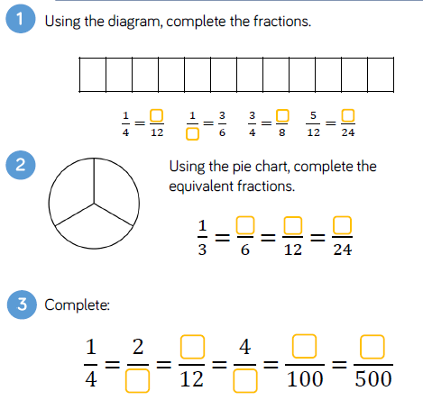

Use it!

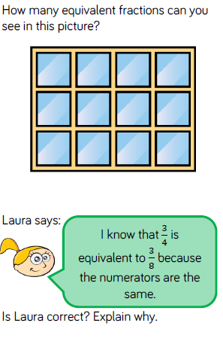 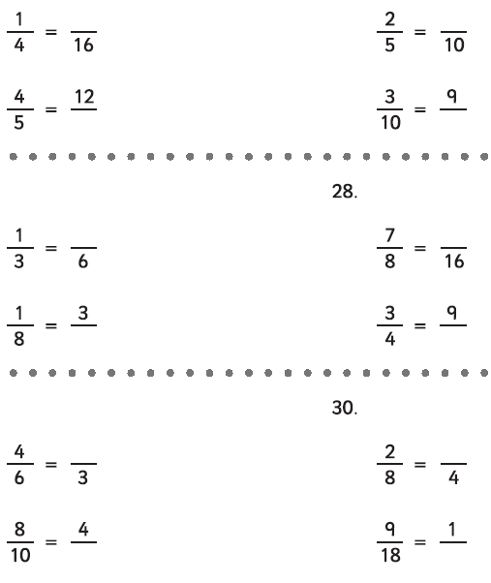

Own it!

