Solve these calculations in your book, write out the question.
Should | Could | Challenge
Perimeter of rectangle with sides:  - 3cm and 4cm  - 2cm and 8cm  - 6cm and 9cm  - 7cm and 13cm  - 6cm and 14cm | Perimeter of rectangles with sides:  - 13cm and 4cm  - 4cm and 18cm  - 15cm and 9cm  - 6.5cm and 13.5cm  - 16.5cm and 4.5cm | Which of these perimeters is for a square (whole cm sides)? Explain how you know.  - 16cm  - 24cm  - 35cm  - 49cm

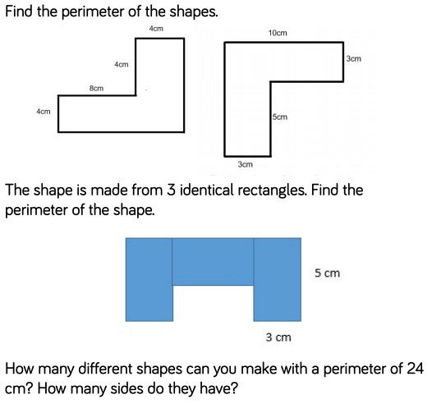
Do it!

Use it!
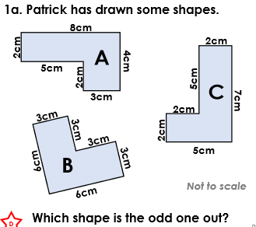
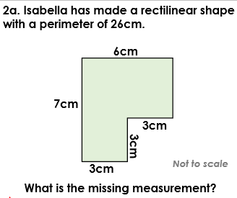

Own it!
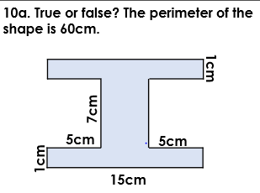  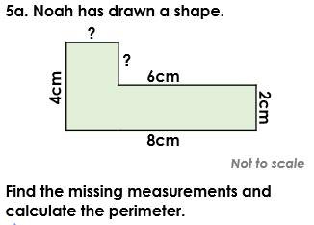 | 