Learning Objective: to be able to write decimals
Should | Could | Challenge
What are these decimals?  2 tenths, 7 hundredths  12 tenths, 24 hundredths | What are these decimals?  15 tenths, 50 hundredths  32 tenths, 6 hundredths | What are these decimals?  102 tenths, 102 hundredths  50 tenths, 55 hundredths

Do it!
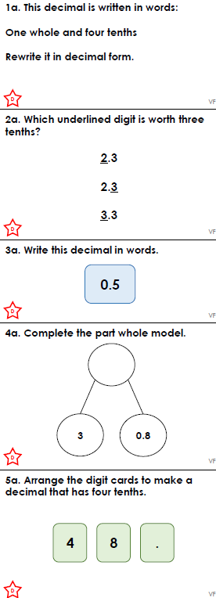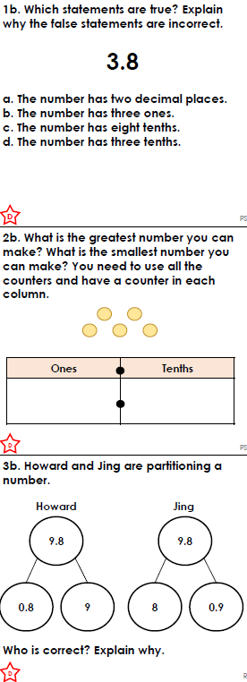
Use it!
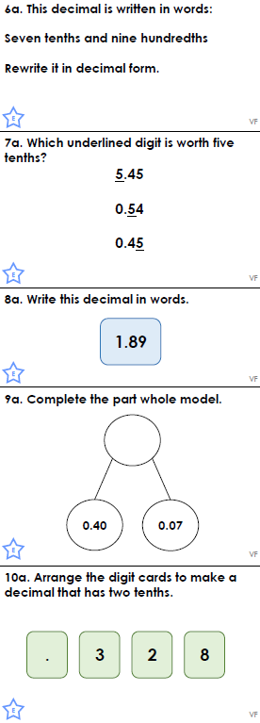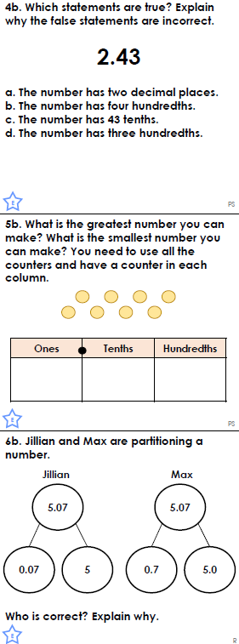
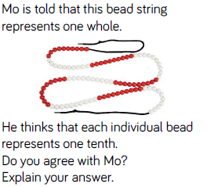

Own it!
