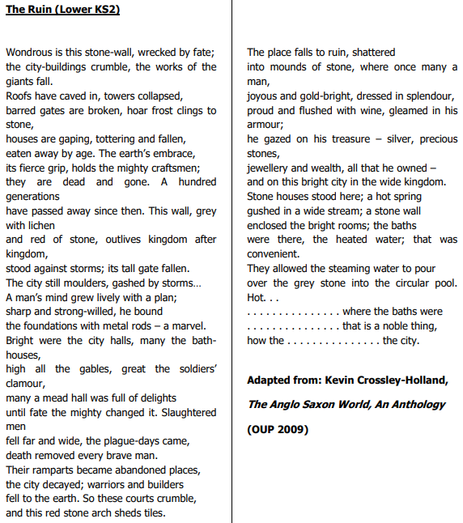
This is an Anglo Saxon poem, The Ruin
A. Read the poem twice. Look up any words that you do not understand.
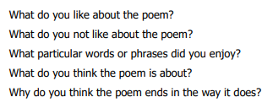
B, Answer these questions:

