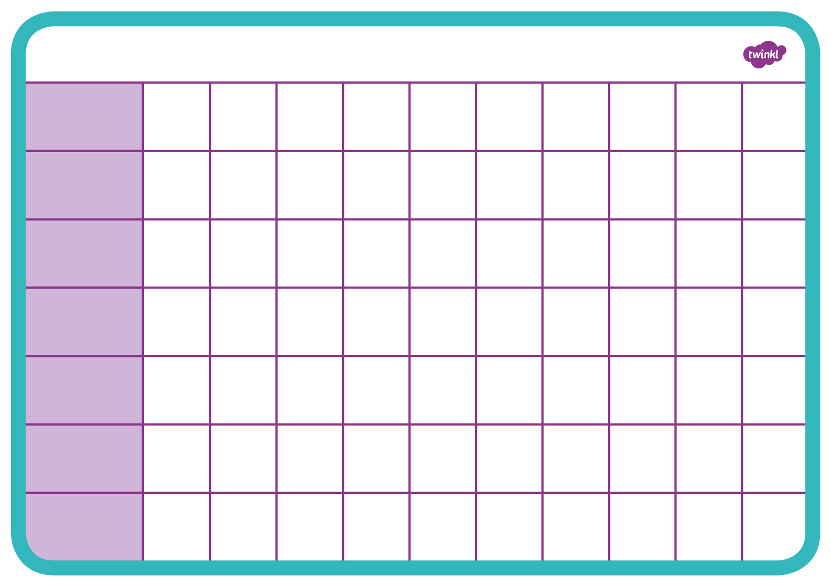

|  |
| --- |
| Wednesday |

|  |
| --- |
| Tuesday |

|  |  |
| --- | --- |
| |  | | --- | | **Monday** | |

**Timetable**

|  |
| --- |
| Sunday |

|  |
| --- |
| Saturday |

|  |
| --- |
| Friday |

|  |
| --- |
| Thursday |

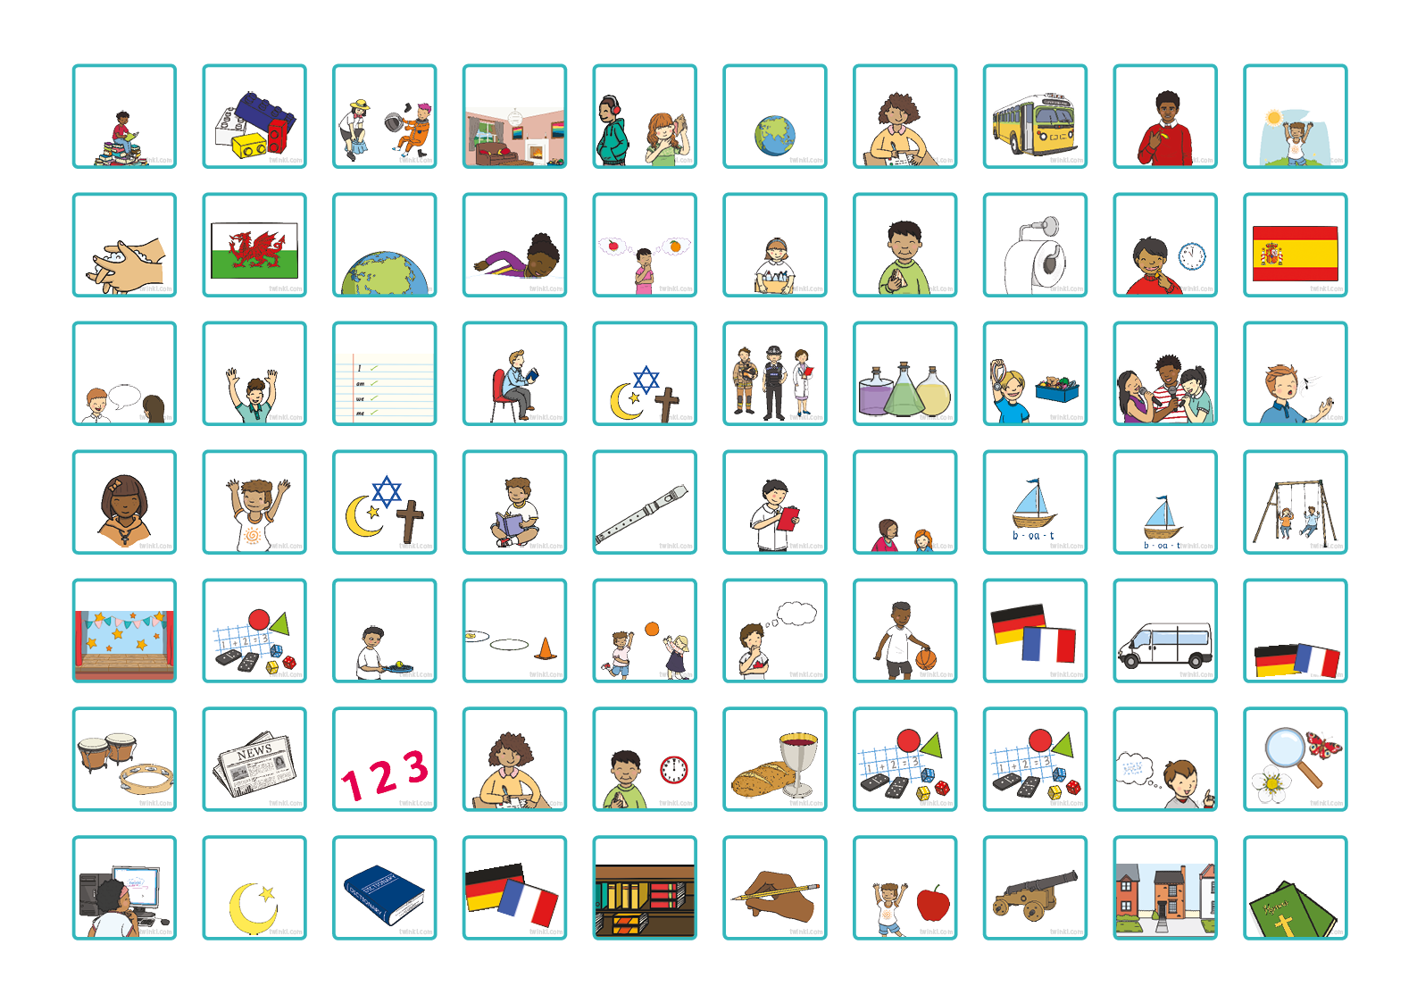

Book Corner

Toast Time

Modern Foreign Languages

Home Time

Swimming

ICT

Islamic Studies

Language

Languages

Library

Handwriting

Health and Wellbeing

History

Hymn Practice

Music

News

Number Work

Literacy

Lunch Time

Mass

Mathematics

Maths

Mental Maths

Investigation

Practice

Numeracy

Outdoor Activities

Outdoor Activity

Outdoor Games

P4C

PE

MFL

Minibus Time

Prayers

PSHE

RE

Reading

Recorders

Register

Personal, Social and Emotional Development

Phonics

Phono Graphix

Play Time

Speaking and Listening

Special Activity

Spellings

Story

Religious Education

Role Play

Science

Show and Tell

Singing

Singing Practice

Washing Hands

Welsh

World Around Us

Thinking Skills

Tidy Up Time

Toilet

Snack Time

Spanish

Wake and Shake

Visitor

Trip Out

Writing

Small World

Listening Area

Home Corner

Dressing Up

Construction

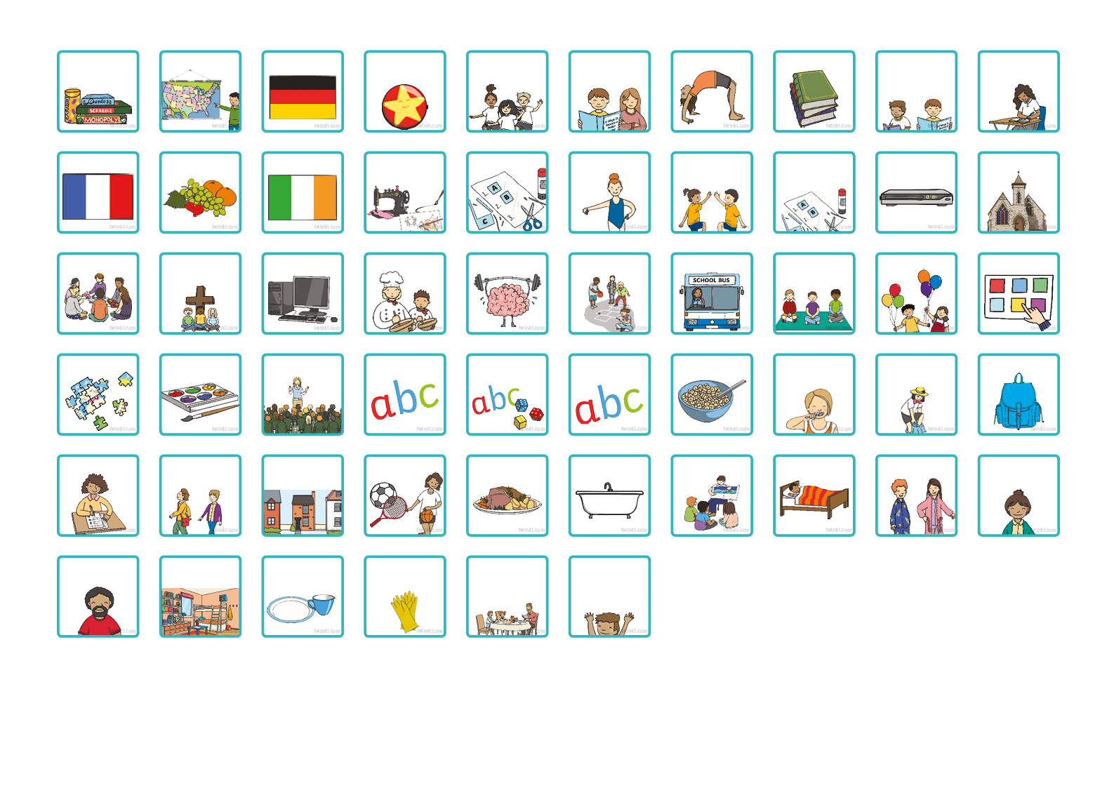

Personal, Social and Health Education

Bath

Story

Bed

Pyjamas

Mummy Pick Up

Big Writing

Breakfast

Brush Teeth

Get Dressed

Pack Bag

Break Time

Bus Time

Carpet Time

Celebrations

Choosing

Dance

Dance and Movement

Design and Technology

DVD Time

Church

Focus Tasks

Everyone Reading in Class

English

Gymnastics

Guided Reading

Daddy Pick Up

Clean Bedroom

Empty Dishwasher

Clean Bathroom

Set the Table for Dinner

Homework

Walking to School

Going Home

Sports

Dinner

Activities

Art

Assembly

Big Write

Big Write Games

Circle Time

Collective Worship

Computers

Cooking

Brain Gym

French

Fruit Time

Gaeilge

Creative Curriculum

D & T

Group Work

Golden Time

German

Geography

Inside Activity